**Name: Sreelekshmi Anilkumar**

**Roll No: 42**

**Batch: MCA B**

**Date: 24-03-2022**

**NETWORKING & SYSTEM ADMINISTRATION LAB**

**Experiment No.: 3**

**Aim:**

Familirization of Linux Commands.

**Procedure:**

1. Pwd :- Print the Current working directory path, starting from the root.

$pwd

**Output Screenshot**

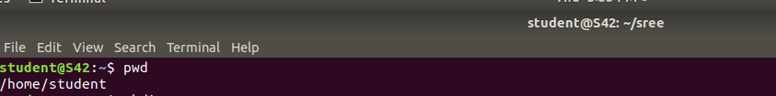

1. Mkdir :- Allow users to create or make a new directories.

$mkdir sree

$pwd

**Output Screenshot**



1. ls :- The command used to list files or directories in linux based operating system.

$ls

**Output Screenshot**

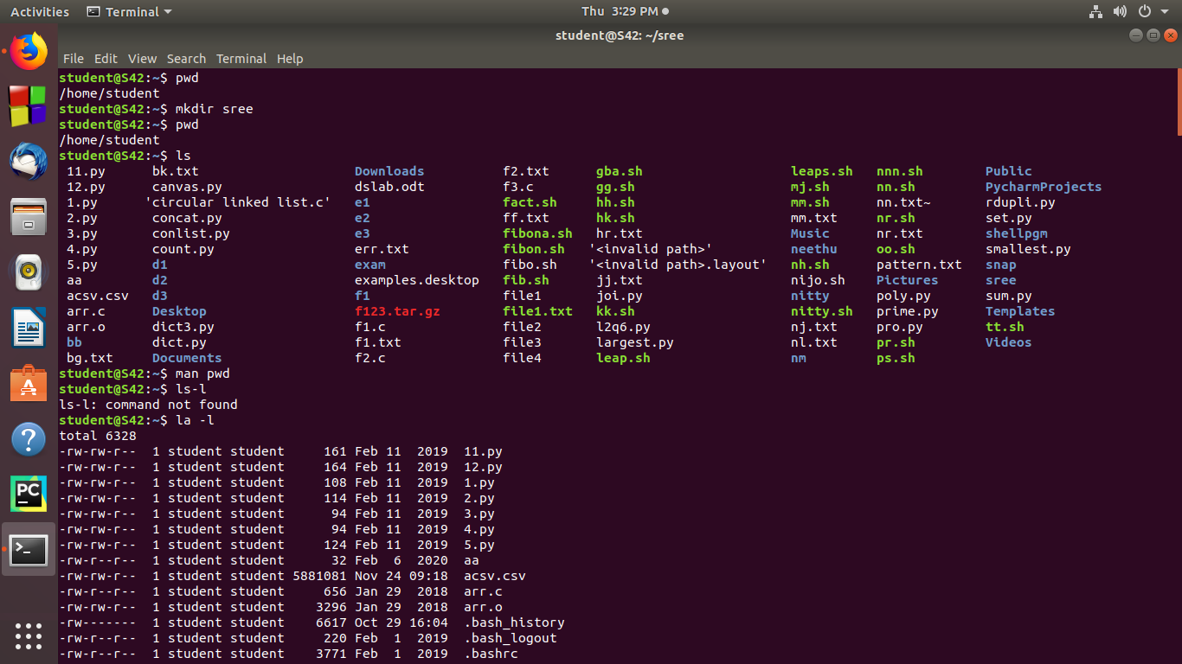

* 1. ls -l :- It is used to list information about files and directories with in the file

system.

$ls -l

**Output Screenshot**



* 1. ls -R :- The ls command list the files inside a folder.

$ls -R

**Output Screenshot**

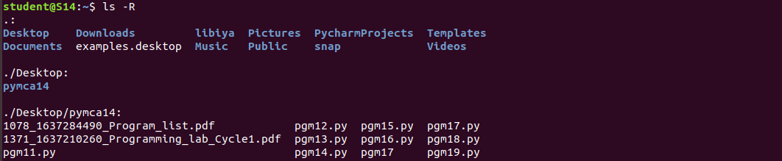

* 1. ls -a :- The command will enlist the whole list of the current directory including

the hidden files.

$ls -a

**Output Screenshot**

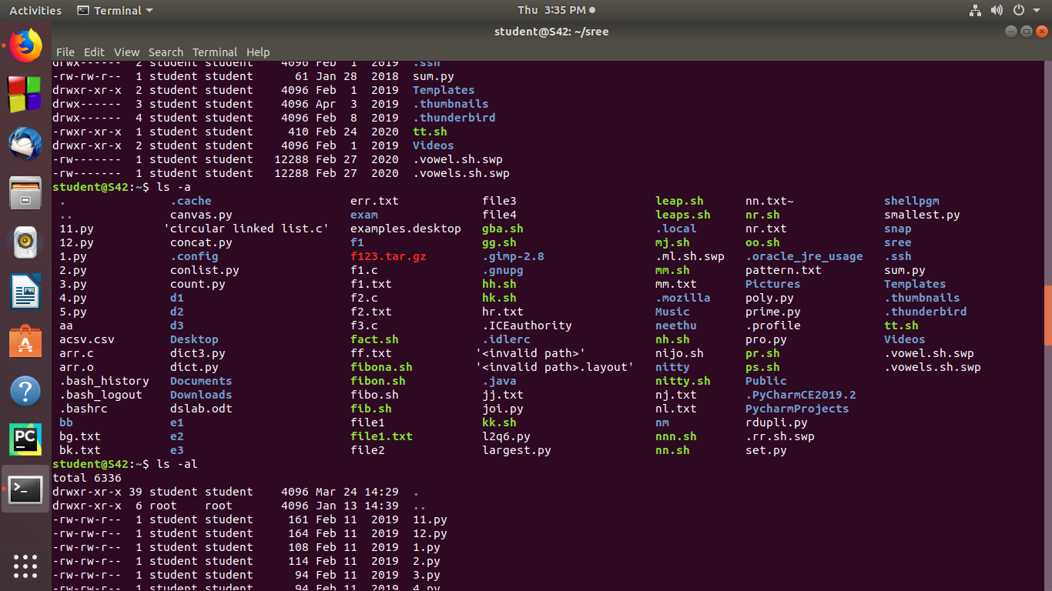

* 1. ls –al :- Is used on linux operating systems to list information about files.

$ls –al

**Output Screenshot**



**3.5**  ls –t :- It sorts the file by modification time, showing the last edited file

first.

$ls –t

**Output Screenshot**

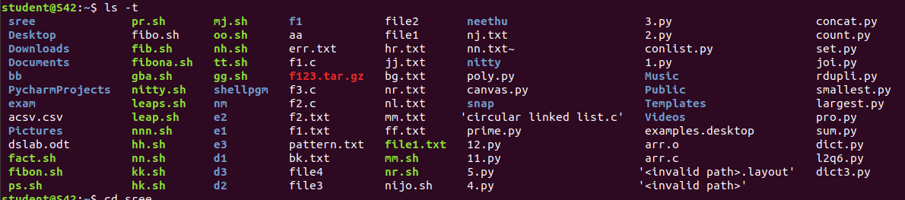

1. cd :-Change the current working directory.

$cd sree

**Output Screenshot**



1. cd.. :-Move to the previous directory.

$cd..

**Output Screenshot**



1. cd- :- Traverse the previous directory.

$cd-

**Output Screenshot**



1. cat :-Create a new file and add content to the file.

$cat > a.txt

**Output Screenshot**



1. cat filename :-for viewing the file

$cat a.txt

**Output Screenshot**



1. cat >> filename:- For adding additional information to that file.

$cat >> a.txt

**Output Screenshot**



1. cat file1 > file2 :- To copy file content of one file to another file.

$cat a.txt > b.txt

1. $cat b.txt :- To put the line numbers.

**Output Screenshot**

